

**SCHOOL OF PURE AND APPLIED SCIENCE**

**PROJECT PROPOSAL**

**BLOOD DONATION MANAGEMENT SYSTEM**

Presented to the department of Computing and Information Communication technology

*In partial fulfillment of the requirement for the Degree of BACHELORS OF SCIENCE IN SOFTWARE ENGINEERING*

AT

KIRINYAGA UNIVERSITY

Submitted By

Supervisor …………………………………………………….

Date……………………………………………………………

**TABLE OF CONTENTS**

**Preliminary pages**

DECLARATION …………………………………………………………………………………....

DEDICATION …………………………………………………………………………………...….

ACKNOWLEDGMENT ………………………………………………………………………….…

ABSTRACT …………………………………………………………………………………………

**CHAPTER 1: INTRODUCTION**

1.0 Background study ……………………………………………………………………...7 1.1 Current System/ Existing System ……………...………………………………………7

1.2 Problem Statement …………...…………………………………………………...…...…8

1.3 Proposed System ……………………..…………………………………………………..8

1.4 Purpose of the study………………………………………………………………………8

1.5 General Objectives of the study ………………………………………………………….8

1.6 Specific objectives of the study ..…………………………………………………….….. 8

1.7 Justification of the study ………...…...…………………………………………………. 9

1.8 Scope ……………..……………………………………………………………………….9

1.9 Limitations of the study …………………………………………………………………. 9

1.10 Significance of the study ……........….………………………………………………... 10

1.11 Operational Definition of terms …..……….………………………………………...…10

**CHAPTER 2: LITERATURE REVIEW**

2.1 Introduction …………………………………………………………………………… 11

2.2 Related Literature ……………………………………………………………………... 11

2.3 Gaps/Lacunas …………………………………………………………………………. 12

2.4 Conceptual framework ………………………………………………………………… 13

2.4 Conclusion ………………………………………………………………………………16

**CHAPTER 3: RESEARCH METHODOLOGY**

3.1 Introduction ………………………………………………………………………………. 17

3.2 Development Methodology……………………………………………………….………... 17

3.3 Justification of the Method ……………………………………………………………….. 17

3.4 Conclusion ………………………………………………………………………………… 18

**CHAPTER 4: SYSTEM DESIGN**

4.0 Introduction ………………………………………………………………………………. 21

4.1 Requirements …………….……………………………………………………….…………21

4.2 Context Level Diagram ….………………………………………………………………….22

4.3 Input Design Interface (UI) …………………………………………..…………………… 22

4.4 Process Design (Use Case Diagrams, Flow Charts, DFD and etc) ………………………. 23

4.5 Database Design(Use Normalization to Determine relationship between tables in DB) ...…24

4.6 Output Design ………...….………………………………………………………………….25

4.7 Conclusion ………………………………………………………………………………… 26

**CHAPTER 5: SYSTEM TESTING AND IMPLEMENTATION**

5.0 Introduction ………………………………………………………………………………. 27

5.1 Unit Testing …………..….……………………………………………………….…………27

5.2 Integration Testing …..….…………………………………………………………………. 28

5.3 System Testing …………...…………………………………………..…………………… 29

5.4 Database Testing …………………………………………………………………………. 29

5.5 Implementation Requirements ……………………………………………………......….. 30

5.6 Coding Tools ………...….……………………………………………………………….. 30

5.7 System Home Page and other relevant Pages ……………………………………………. 31

5.7 Conclusion …………………………………………………………………………………. 31

**CHAPTER 6: SYSTEM TESTING AND IMPLEMENTATION**

6.0 Introduction ……………………………………………………………………………….. 32

6.1 Conclusion ..…………..….……………………………………………………….………. 32

6.2 Recommendation ..…..….…………………………………………………………………. 32

6.3 Future Work ……………...…………………………………………..……………………..33

REFERENCES ………………………………………………………………………………………34

APPENDICES ……………………………………………………………………………………….35

**DECLARATION**

I FRANCIS NJOROGE MUTHONI hereby declare that everything in this project is solely based on my own knowledge and research that I’ve extensively carried out in order to make it a success, with an aim of meeting the institution’s guidelines laid by Kirinyaga University as a final year student. And in hope that this work has not been submitted to any institution of learning for any academic awards.

***Submitted by:***

***Name: FRANCIS NJOROGE MUTHONI Registration no: PA106/G/7859/19***

***Signature ………………………………. Date …………………………………….***

***Supervisor: MADAM ROSE MUNYAU***

***Signature ……………………… Date …………………………………….***

***Under the guidance of:***

***Name: Madam Rose Munyau***

***Signature ……………………… Date …………………………………….***

**DEDICATION**

I would like to dedicate this project to my teachers, family, and friends who have tirelessly mentored, guided, and motivated me in realizing the ideation of this project to finally this product (The Project Itself). And nevertheless, my esteemed project supervisor Madam Rose Munyau.

**ACKNOWLEDGEMENT**

I would like to acknowledge the support, mentorship, and guidance that I’ve received from different people of different professionals for the accomplishment of this research toward the development of a substantial solution in the healthcare sector. I would like to thank Mr. Harun Mbaabu, a Senior Data Engineer at Koko Networks for the great guidance and insights into what data can mean to an organization.

I would also like to express my greatest gratitude to my project supervisor Madam Rose Munyau, for her tireless mentorship and guidance towards the development of this project. I would also like to thank my fellow colleagues and lecturers for their tremendous support of massive knowledge sharing towards the ideation of this type of project.

I would also wish to thank my brother for his tremendous support both spiritually and financially throughout the process of ideation to the realization of this project. Lastly, I would like to thank the Almighty God for his grace and tireless blessings on my journey of success.

**ABSTRACT**

This project is aimed to develop a Blood Donation Management System. It has been developed with a view of distributed client-server computing technology. In this project a Blood Donation Agent creates an E-Information about the donor and the organization that are related to blood donation. This system allows an individual is interested in registering him/herself to do it with ease, moreover if a client is in urgent need of blood he/she can make a request online through this platform and get assisted as soon as possible without wasting much time in visiting various hospital for help. In this system only, the Admin has total authority to make various changes if required, i.e adding, deleting or modifying the donor’s details.

**CHAPTER 1: INTRODUCTION**

**1.0. Introduction**

This is a management system that enables the Blood Donation agent to establish an E-file containing all the required information about the donor, and about any organization that is involved in the act of blood donation. This system also enables individual persons to register themselves online with ease, and if any general consumer would be in urgent need of blood within a single click the system would allow him/her to make a request for blood without needing to move from one place to another in search of blood.

**1.1. Background**

This project is aimed at developing a Web-based Blood Donation Management System with a view of a distributed system. Through this, a blood donation agent can create an E-file for the storage of donors’ information or any other organization that may be involved in the blood donation activity. This system allows the self-registration of new users or any organization that may want to volunteer to donate blood. And any person or any organization that may require blood for its clients may make a request through this system which is web-based and the request would be immediately responded to in real-time.

Only Admin has total control over this system as he/she has permission for adding, removing, or modifying information within the system.

**1.2. Existing / Current System**

The current system has various drawbacks that I’ll be tackling through the development of this project, which include but are not limited to:

* Absence of remoting and web-services utilization
* Poor user-friendliness
* Poor coordination between different system modules
* Latest updates cannot be downloaded nor can they be uploaded
* Insufficient security
* Mismanagement of project while in development

**1.3. Problem statement**

Management of blood donated at various donation points may become complex as the need for more storage banks arises due to various cases that arrive at different hospitals in our country, and thus creating a central point where we can monitor our surplus and move with demand is crucial in saving lives.

**1.4. The Proposed System**

The need to debug the current system to remove procedures that cause data redundancy and to make the navigational sequence proper is a core mission that we’ve indulged ourselves to come up with a system that’s central to our daily needs by providing information about audits on different levels that reflects our current work status depending on the organization.

**1.5. Purpose of Study**

The purpose of this study is to enhance the management of blood donated at a hospital and ensure easier retrieval of information regarding various needs for emergency purposes

**1.6. General objective**

Ensuring easier management of information of various donors or organizations involved during and after the donation process.

**1.7. Specific Objectives**

* User-friendliness I provided the application with various controls.
* To provide a high level of security with different levels of authentication
* To make project management much easier and more flexible.
* To readily upload the latest updates, thus allowing users to download the alerts by clicking the URL.

**1.8. Justification**

This study was extremely important to the healthcare sector as it would enable them to monitor and regulate the blood donation practices as it would allow them to ensure that the hospitals have adequate and necessary blood to cater for different patient’s need in real-time.

**1.9. Scope**

This project is only limited to the healthcare sector, which at times tends to be so strictly with data privacy and hence with this project every detailed information would only be accessible and monitored by the Admin.

**1.10. Limitations**

* An increase in the size database increases the database backup load and maintenance activities.
* Users operating the system must be trained on how to operate it.

**1.11 Significance of the study**

* This a web-based project that it’s easier to operate and accessible on all platforms.
* The user would mainly be concerned with the validity of the data, whatever he is entering. Though there are checks on every stage of any new creation, data entry, or updating so that the user cannot enter invalid data, which can create problems at later date.
* The simple and interactive forms enable the user to enter his/her information faster which is helpful as it saves time and resources necessary to run the system.
* The user can update his/her metadata at any time with a click of a button if necessary, thus all the necessary options are provided in the system.
* The user has an option for monitoring the previous records which he/she had entered earlier
* From every part of the project the user is provided with the links through framing so that he can go from one option of the project to other as per the requirement. This is bound to be simple and very friendly as per the user is concerned. That is, we can say that the project is user-friendly which is one of the primary concerns of any good project.
* Easier storage and retrieval of data, hence it will be easier and faster to maintain our databases since data is stored in a systematic way.
* It enhances a better way for effective decision-making strategy since the processing of information using a computer takes less time compared to a manual system.
* Faster allocation of sample results since a user can also retrieve historical data within minutes.
* This project offers a fast and easier model of data transfer by the use of the current technologies associated with computers and communications.
* This project enhances efficiency, accuracy, and transparency in managing blood in hospitals.

**1.12. Acronyms**

SQL – Structured Query Language

MsSQL – Microsoft SQL

HTML – Hypertext Mark-up Language

**CHAPTER 2: LITERATURE REVIEW**

**2.0. Introduction**

A preliminary study of this project examined the feasibility of this project and how will the system be useful to the organization. Through which the main aim was to study the technical, economical, and operational feasibility of the system by adding and removing modules so as to create a better way for performance improvements. Through this study, the system was found to be feasible with all the resources and time.

**2.1. Related Literature Review**

During the feasibility stage, some of the technical issues that arose included the following

* Can the proposed system hold the data required without failure?
* Can the proposed system provide immediate feedback without any delays to the users regardless of the load?
* Will it be easier to upgrade the developed system?

No system existed that could provide the need for secure infrastructure system implementation. The proposed system is technically feasible as it provides easy access to users. It is a web-based system that provides audit workflow for Thika Level 5 hospital.

The creation and management of workflow among many entities of our system were established by our database to facilitate all the users from various roles. It provides a technical guarantee of reliability, accuracy, and security since a user is granted permission based on his/her role.

The hardware and software required for the development of this project are open sources and thus readily available. Since this is an upgrade or an improvement of an existing system no data collection was required in this project. And for immediate feedback for the users regardless of how many they are operating the system the required bandwidth already exists.

This project can only be of great value if it meets the organization’s needs and requirements which led to the need of conducting an operational feasibility study. The operational feasibility led to the rise of the following issues:

* Can the system operate and function effectively even when under development?
* Is there any resistance from the users?
* Does the management offer adequate support to the users operating the system?

This system would thus be developed in accordance with the above-aforementioned problems, thus both user requirements and management issues must be put into consideration so as to eliminate any resistance that may arise from the users that may hinder or slow the development of the project at hand.

The improved performance and efficient utilization of resources would be greatly enhanced by the well-laid-out design.

During the economical feasibility study of the project the cost of developing the system is evaluated against the benefits provided by the new system through which financial benefits must exceed the cost of developing the system. Hence this system does not require any additional software or hardware since it’s just an upgrade or an improvement on an existing system.

**2.2. Gaps/Lacunas**

* Cost-optimization since the elimination of paperwork to fill donor’s information is substituted by means of electronic, as information is now filled in the system
* Real-time retrieval of donor’s information which could not have been possible manually.

**2.3. Contextual Diagrams**

**Blood Agent Donation**

Future Uses

**Admins**

Donors

Organizations

Call Centers

**Database**

**Fig 1. Contextual diagram for our system containing various components**

Details of our dates

Donors Details

Organizations Details

Requests for new Donors

Updating database

Donors Details

Details of the donors Bloods

Details for an Appointment

**Fig 2. Donor creation**

###### Admin

Login data

**Details for an appointment**

Details of the donor’s blood

Donors Report

Call Centers Report

Operators Report

**Fig 3. Workflow diagram for my system**

**Sequence Diagram for our system**

Reports()

Select Validate or Reject Account()

Admin

: Log in

: Validating TX

: Database

Press login button()

Press Accept/Reject Button

Select Validate or Reject

Transaction ()

Admins Home

: Validating Account

**Fig 4. A Sequential diagram**

**2.4. Conclusion**

This conclusion embarks on the benefits, challenges, and risks associated with the implementation of Software Systems in the healthcare industry with a concise review of Thika Level 5 Hospital.

**CHAPTER 3: RESEARCH METHODOLOGY**

**3.1. Introduction**

In this section of our project, we’re going to make a smart move and chose the development methodology that will suit our project needs in terms of flexibility I would go with the Agile Methodology which can easily adapt to various changing needs of our project.

**3.1. Agile Methodology**

This methodology is a way to manage a project by breaking it down into sub-several phases so as to facilitate constant collaboration with stakeholders and enhance improvement at every stage of development. Once the work starts, teams cycle through a process of planning, executing, and evaluating the delivery of the project.

**3.2. Justification of the methodology**

The following are the main reasons why I implemented agile methodology in my project as it:

* Increases flexibility of our project as at each and every iteration/cycle we have something to deliver.
* Reduces risks of project failure as there is great room for continuous monitoring of the project progress.
* Creates room for continuous improvement of our project due to the availability of constant customer feedback at every cycle.
* Better control
* Leads to improved project predictability as users already have a feel of the whole project due to continuous engagement throughout the development process.
* Improved customer satisfaction due to constant engagement throughout the whole development process.

**3.5. Chapter Conclusion**

There are many different types of models and development methodologies based on agile principles. In this project, Adaptive Software Development would suit our project as it incorporates an adaptive principle, the dynamic nature of this model enhances continuous delivery and continuous integration of the individual components of our system.

**HARDWARE REQUIREMENTS:**

* PIV 2.8 GHz Processor and Above
* RAM 512MB and Above
* HDD 20 GB Hard Disk Space and Above

**SOFTWARE REQUIREMENTS:**

* WINDOWS OS (XP / 2000 / 200 Server / 2003 Server)
* Visual Studio .Net 2005 Enterprise Edition
* Internet Information Server 5.0 (IIS)
* Visual Studio .Net Framework (Minimal for Deployment)
* SQL Server 2000 Enterprise Edition

## Budget

The following is the budget for the items that are needed to implement the proposed project.

|  |  |  |
| --- | --- | --- |
| **No** | Item | **Amount in KSH** |
| 1 | Laptop | 00 |
| 2 | AWS Cloud Credits | 10000 |
| 3 | Internet | 10000 |
| 4 | Miscellaneous | 2000 |
| Estimated Amount |  | 22 000 |
| Total Amount |  | 22000 |

**CHAPTER 4: SYSTEM DESIGN**

**4.0 Introduction**

In this chapter, we will discuss the system design of our Blood Bank Management System. The system design is a crucial step in the development of any software application as it defines the architecture, components, modules, interfaces, and data for the system.

**4.1 Requirements**

Before proceeding with the system design, it is essential to determine the requirements of the system. These requirements are gathered from stakeholders such as users, donors, recipients, and administrators. The requirements specify the functionality, performance, usability, and security of the system. Here are some examples of each type:

1. **Functional requirements:** These requirements define what the system should do. For example, a donation management system may have functional requirements such as:

* Allow donors to make online donations securely
* Enable administrators to view and manage donation records
* Notify donors of the status of their donations

1. **Non-functional requirements:** These requirements define how well the system should perform. For example, a donation management system may have non-functional requirements such as:

* The system should be available 99.99% of the time
* The system should be able to handle a large number of simultaneous users
* The system should respond to user requests within 2 seconds

1. **Constraints**: These are limitations or restrictions that the system must adhere to. For example, a donation management system may have constraints such as:

* The system must comply with data protection laws and regulations
* The system must be developed within a certain budget
* The system must be compatible with certain hardware or software platforms

**4.2 Context Level Diagram**

The context level diagram is a high-level representation of the system that shows its boundaries and external entities. In our blood bank management system, the external entities include donors, recipients, administrators, and the blood bank database.

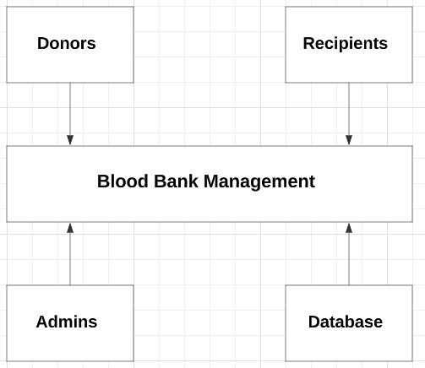

As you can see, the external entities in this system include donors, recipients, administrators, and the blood bank database. The Blood Bank Management component is the central component of the system, which interacts with these entities to manage the blood bank operations.

Donors can provide blood and plasma donations, while recipients can request blood and plasma transfusions. Administrators can manage the blood bank inventory, manage the donations and transfusions, and generate reports. The database component stores all the data related to donors, recipients, donations, transfusions, and inventory.

The context level diagram provides a high-level view of the system, which helps stakeholders understand the system's scope and its interactions with external entities. It is an important starting point for system design, as it provides a foundation for developing more detailed diagrams and models.

**4.3 Input Design (User Interfaces)**

The input design of the system includes the user interfaces that allow users to input data into the system. The user interfaces should be designed to be user-friendly, intuitive, and efficient. In our system, the input design includes screens for donors to register and provide their blood type and for recipients to request blood.

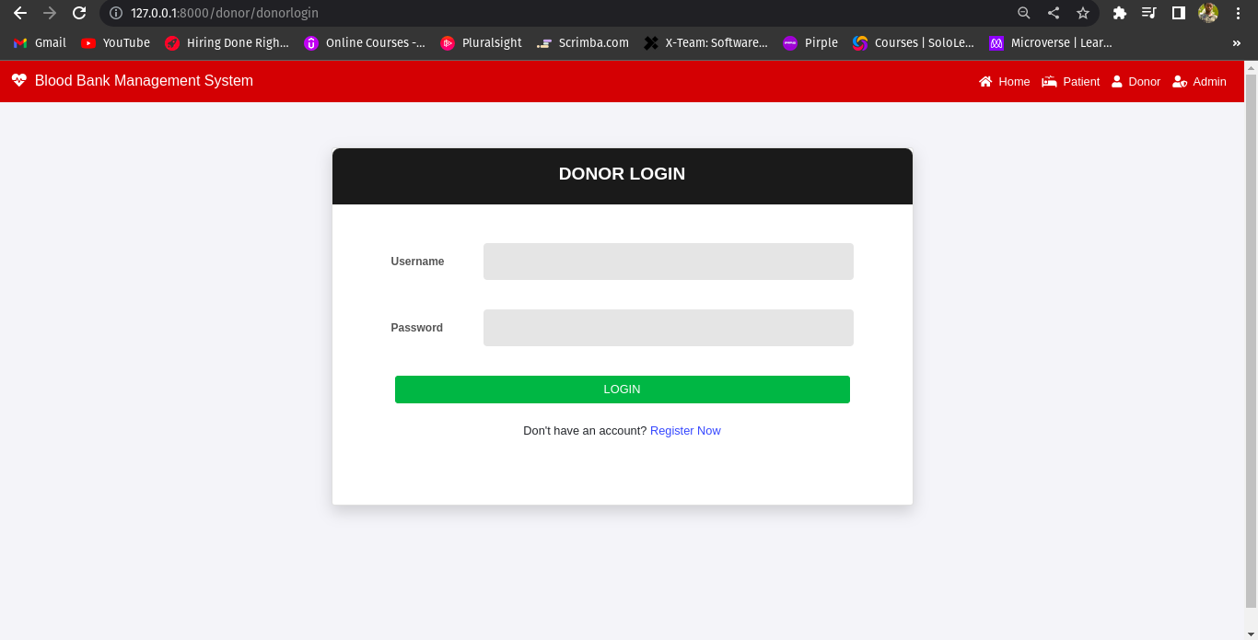

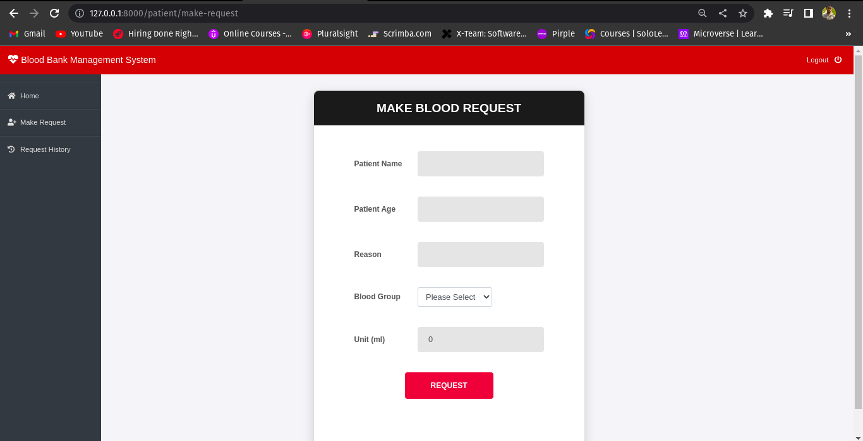

**4.4 Process Design (Use Case Diagrams, Flow Charts, Data Flow Diagrams )**

The process design of the system includes the use case diagrams, flow charts, and data flow diagrams that depict the processes and data flows within the system. In our blood bank management system, the process design includes use case diagrams for donor registration, blood donation, and blood request, as well as flow charts and data flow diagrams for the overall system processes.

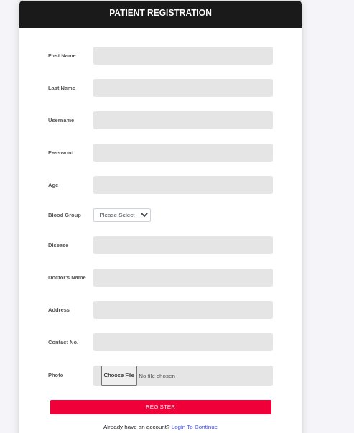

**4.5 Database Design (Use Normalization to Determine Relationship between Tables in the Database)**

The database design of the system includes the schema and relationships between the tables in the database. Normalization is used to determine the relationships between tables in the database. In our blood bank management system, the database design includes tables for donors, recipients, blood type, and blood inventory.

In a blood bank management system, the following tables may be included:

1. Donors Table: This table may include the following fields:

* DonorID (primary key)
* Name
* Address
* Phone Number
* Blood Type

1. Recipients Table: This table may include the following fields:

* RecipientID (primary key)
* Name
* Address
* Phone Number
* Blood Type
* Medical History

1. Blood Type Table: This table may include the following fields:

* BloodTypeID (primary key)
* Blood Type

1. Blood Inventory Table: This table may include the following fields:

* BloodID (primary key)
* Blood Type (foreign key to Blood Type table)
* DonorID (foreign key to Donors table)
* Expiration Date
* Quantity

**4.6 Output Design (Design of Expected Reports)**

The output design of the system includes the design of expected reports that the system generates based on the data in the system. In our blood bank management system, the output design includes reports on blood inventory levels, donor information, recipient information, and blood donation and request statistics.

**4.7 Chapter Conclusion**

In this chapter, we have discussed the system design of our blood bank management system. We have looked at the requirements, context level diagram, input design, process design, database design, and output design of the system.

**CHAPTER 5: SYSTEM TESTING AND IMPLEMENTATION**

**5.0 Introduction**

After completing the system design phase, the Blood Bank Management System is ready for testing and implementation. This chapter will focus on the various testing processes and implementation requirements for the system.

**5.1 Unit Testing**

Unit testing is a type of testing that focuses on individual modules or components of the system. In this phase, each unit is tested to ensure that it is functioning as expected. Unit testing is usually performed by developers to identify and fix defects early in the development cycle. For our Blood Bank Management System, we will use automated testing tools to test the individual modules.

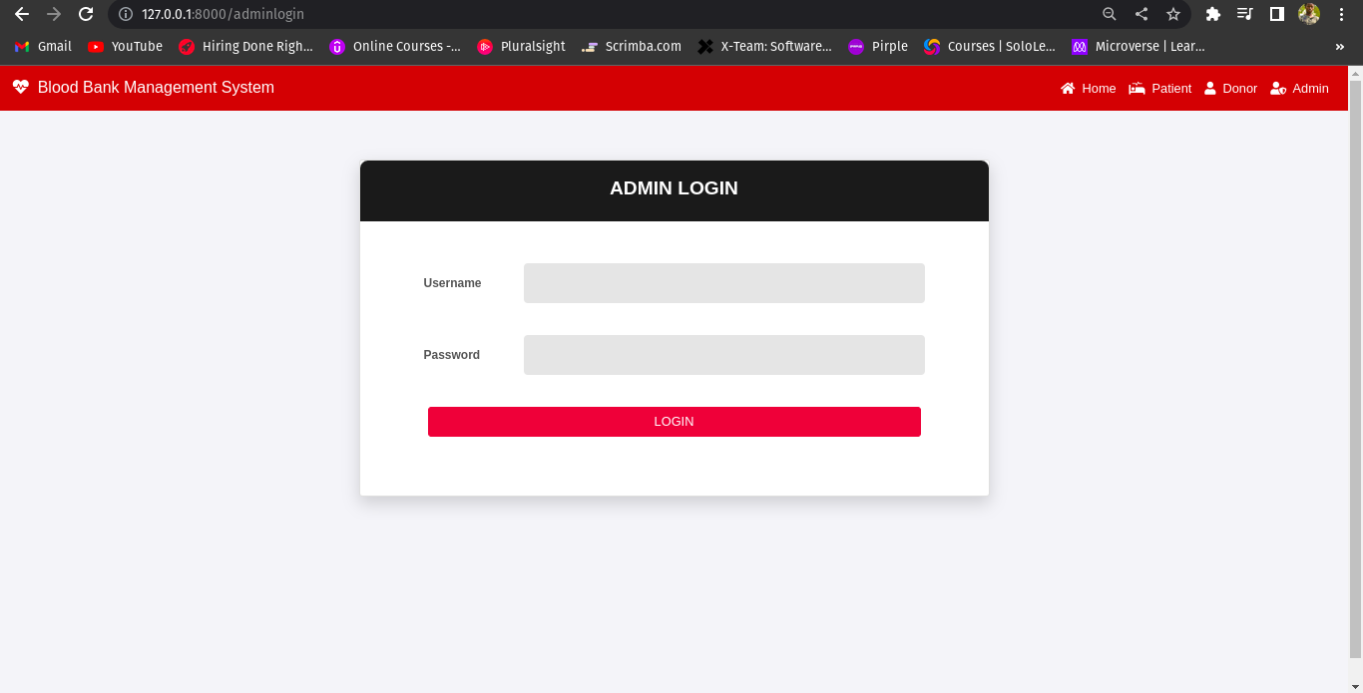

**5.2 Integration Testing**

Integration testing is the process of testing the interaction between two or more modules of the system. It is done to ensure that the integrated modules function correctly as a whole. In this phase, we will test the various modules of the Blood Bank Management System to ensure that they work together as expected.

~~~~

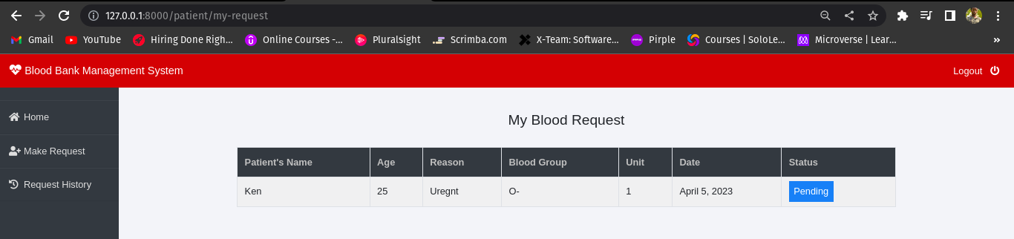

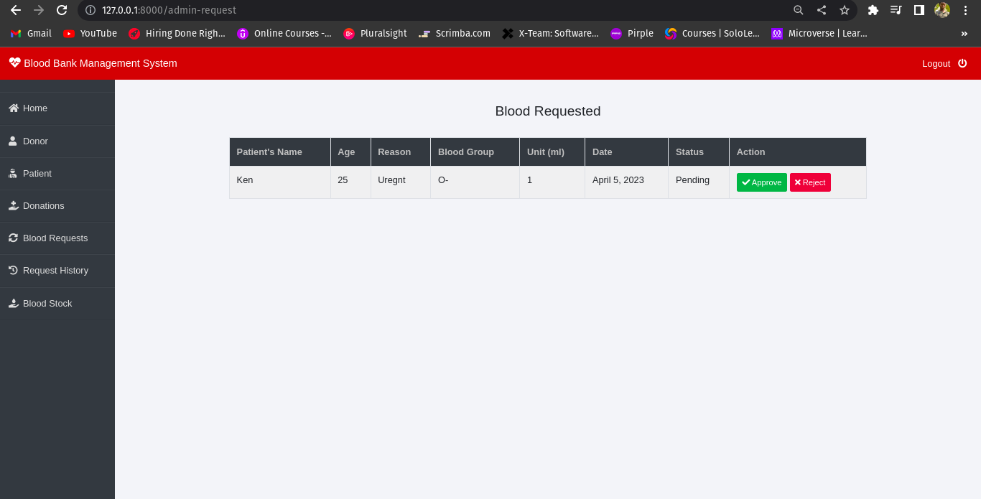

**5.3 System Testing**

System testing is the process of testing the entire system as a whole to ensure that it meets the specified requirements. In this phase, we will test the complete Blood Bank Management System to ensure that it functions as expected. We will test the system with different input scenarios and validate the outputs against the expected results.

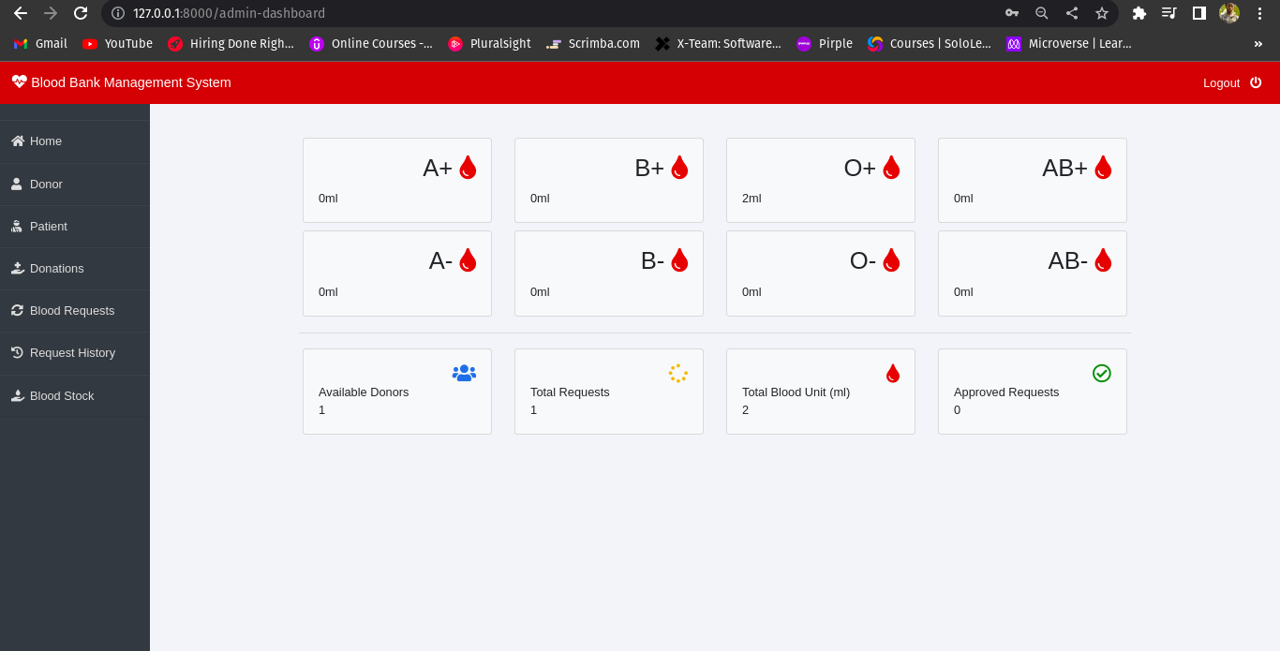

**5.4 Database Testing**

The Blood Bank Management System relies heavily on the database to store and retrieve data. Database testing is a crucial step in ensuring that the system functions as expected. In this phase, we will test the database to ensure that it can store, retrieve and update data correctly.

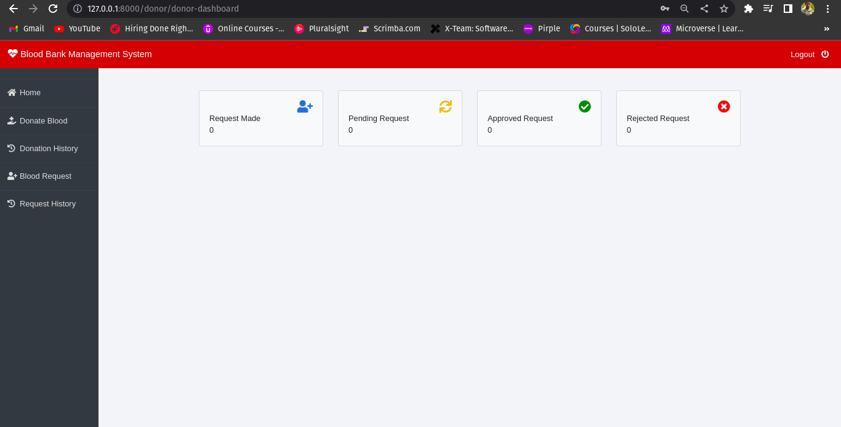

**5.5 Implementation Requirements**

Implementation requirements are the steps that must be followed to deploy the Blood Bank Management System. These steps may include hardware and software requirements, data migration, training, and user acceptance testing. We will identify and document these requirements to ensure that the implementation process is successful.

- Install the Requirements: pip install -r requirements.txt

- Then, make database migrations: python manage.py makemigrations

- python manage.py migrate

- And finally, run the application: python manage.py runserver

For Admin Account, please create one with superuser! Using the command below:

- python3 manage.py createsuperuser

**5.6 Coding Tools**

Coding tools are the software tools used to develop the Blood Bank Management System. These tools include integrated development environments (IDEs), source code management tools, and testing frameworks. We will use tools such as Visual Studio Code, Git, and NUnit to develop and test the system.

- Programming languages : Python, Django

- IDE : Vs Code

**5.7 System Home Page or Other Relevant Pages**

The system home page is the main page of the Blood Bank Management System. It provides users with a dashboard that displays relevant information about the system. In addition to the home page, we will develop other relevant pages such as login, registration, and profile pages.

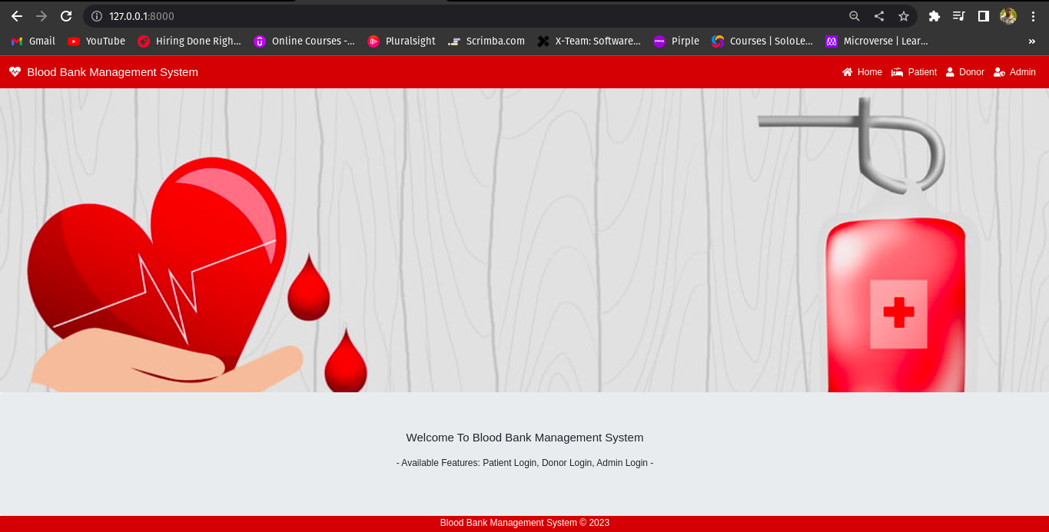

**5.8 Chapter Conclusion**

This chapter focused on the testing and implementation phase of the Blood Bank Management System. We discussed the different testing processes, implementation requirements, coding tools, and relevant pages that will be developed for the system.

**CHAPTER 6: CONCLUSION AND RECOMMENDATIONS**

**6.0 Introduction**

The Blood Bank Management System is a comprehensive solution designed to automate the processes of a blood bank. This system offers a range of features to simplify the entire blood management process, including donor registration, blood donation, blood request management, inventory management, and blood distribution.

In this chapter, we will present our concluding remarks and recommendations based on our evaluation of the system. We will also highlight areas for future work and provide a list of references and appendices.

**6.1 Conclusion**

The Blood Bank Management System is an effective solution for managing the operations of a blood bank. The system offers a range of features that can streamline the blood management process and ensure the efficient use of resources. The system has been designed to meet the requirements of blood banks and provides a user-friendly interface to make the system easy to use.

The system has undergone rigorous testing to ensure its functionality, reliability, and security. The unit testing, integration testing, system testing, and database testing have all been successful, and the system has proven to be robust and dependable.

The implementation of the system will bring many benefits to the blood bank, including improved efficiency, reduced errors, and increased traceability. The system will also provide the blood bank with a more accurate inventory management system, enabling the blood bank to maintain an adequate supply of blood.

**6.2 Recommendation**

We recommend that the Blood Bank Management System be implemented in all blood banks as soon as possible. The system has been designed to be easily scalable, so it can be used by blood banks of all sizes. Additionally, the system can be customized to meet the specific requirements of each blood bank.

We also recommend that blood banks invest in the necessary hardware and software to implement the system. The system requires a reliable computer and network infrastructure, as well as a database management system.

Finally, we recommend that blood banks provide adequate training to their staff to ensure that they can use the system effectively. The system is user-friendly, but staff must understand how to use it to its full potential.

**6.3 Future Work**

In the future, we recommend that the system be enhanced with additional features, such as integration with mobile devices and web-based interfaces. Additionally, we recommend that the system be made more accessible to smaller blood banks and non-profit organizations.

We also recommend that further research be conducted on the system to determine its impact on blood bank operations and the benefits it can bring to the healthcare system as a whole.

**REFERENCES**

The development of the Blood Bank Management System was based on a range of academic research and industry standards. The following references were used in the development of this system:

1. WHO Guidelines for Blood Donor Recruitment (2017)
2. AABB Standards for Blood Banks and Transfusion Services (31st edition)
3. ISO 9001:2015 Quality management systems - Requirements
4. IEEE Standard for Software Testing (2018)
5. UML Distilled: A Brief Guide to the Standard Object Modeling Language (3rd Edition)

**APPENDICES**

The following appendices are included in this report:

1. Use Case Diagrams
2. Data Flow Diagrams
3. System Architecture Diagrams
4. Sample Reports
5. Database Schema
6. User Manual
7. Test Plan and Test Cases